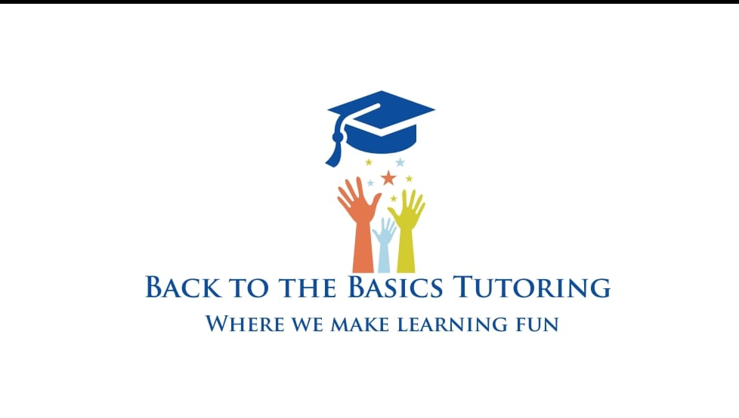
BACK TO THE BASICS TUTORING LLC NOTIFICATION OF BIBLE TEACHING
I understand that this tutoring program is Christian-based and I was made aware by Back to the Basics Tutoring LLC of such. I also understand that my child may be receiving bible lessons as part of the tutoring program. I am aware that the main focuses of the bible lessons are Jesus Christ and God and his dying on the cross for our sins. I am also aware that my child may be given and explained Christian principles. I understand that I or my children do not have to have the same faith or belief to receive the tutoring services; however I understand that if the lessons are given to each child, it will be done as a scheduled activity of the program.
Parent/Guardian Printed Name_____________________________________________________
Parent/Guardian Signature_________________________________________________________
Child Name_____________________________________________________________________
Date___________________________________________________________________________

